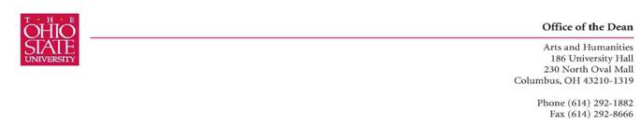
October 13, 2009
Dear Jill, Henry, and Maurice,

The Arts and Sciences Committee on Curriculum and Instruction’s subcommittee for Arts and Humanities met on October 6th and discussed the proposals from Animal Science for GEC status of Diversity: International Issues, Western, Non-US. We looked at Animal Science 248 “Human and Animal Interactions in the United States” and Animal Science 494 “Group Studies” along with 697.04 and 697.05 which serve as a complement to your request. The courses sparked interesting discussions on international issues with relation to the dairy and meat industries, and we had ideas about how the courses could address international issues and ways to compare and contrast US issues with other countries.

In general, before the committee can make a determination, the syllabi for all four courses (248, 697.05, 494, 697.04) need a greater fleshing out of readings (both suggested and required), media assignments, discussions, and an explanation of how the final reports or reflection papers address the learning objectives of this GEC category. Please show how these assignments relate to the learning goals and objectives of the GEC category.

For 248:
The top of the 248 syllabus titled “Human and Animal Interactions in the United States,” indicated they are only looking at US issues. The committee would like to know how the syllabus addresses international issues. Please specify the political, economic, cultural, physical, social and philosophical issues, or some combination of those elements that are international in this course.

What are the topics of discussion that go along with those issues? Although students are to find press releases on problems regarding animals, there is only a chance they will have international perspective, are there readings about an international topic?

Reading should be specified on the syllabus then refer students to Carmen for materials. (page 2)

As this is offered in a cluster with 697.05, we are also concerned with the lack of readings for that course and that the final grade is only based on travel log and reflection paper.

For 494:
Please expand the syllabus to address the expected learning outcomes of the International non-US GEC category within the report assignment and include more information regarding the media releases.
Please include a specific list of readings that is different from the suggested readings.

Please return the updated syllabi to me, and we will review this course again in our November meeting.

Thank you for your commitment to undergraduate education at OSU,

Valarie Williams
Chair, CCI Subcommittee B Arts and Humanities and International Diversity
Professor of Dance
Associate Dean, Arts and Humanities

